

G. H. RAISONI COLLEGE OF ENGINEERING, NAGPUR
(An Autonomous Institute affiliated to Rashtrasant Tukadoji Maharaj Nagpur University, Nagpur)
CRPF Gate No.3, Hingna Road, Digdoh Hills, Nagpur, Maharashtra-440016(India)

DEPARTMENT OF
ELECTRONICS AND TELECOMMUNICATION ENGINEERING

Report
On
‘Product Design and Development’ Workshop –General Proficiency-VI
Research Paper

Names | Roll no | Sign
Jayush Ninawe  (2016AETC0111028)  ninawe_jayush.ghrceet@raisoni.net | 31
Rahul Mudliar  (2016AETC0117133)  mudliar_rahul.ghrceet@raisoni.net | 55

Guided by: -
Dr. Bhushan Vidhale
Department of Electronics and Telecommunication Engineering
bhushan.vidhale@raisoni.net
CANSAT FOR MEASUREMENT OF ELECTROMAGNETIC RADIATION

Abstract—In the above project, the CANSAT is developed and used for spectral analysis of electromagnetic radiation (60-Hz) on the earth’s surface due to electrical power generation and transmission. By collecting the data of this project for a minimum of 6 months, we can analyze the earth’s surface for mapping applications.

Introduction
Ambient electromagnetic radiation can be a problem in many applications where electronic instrumentation is involved, the motivation for this project stems from such a problem. Electro-encephalogram (EEG) readings, in particular, can be adversely affected by the presence of ambient 60-Hertz radiation. The first aim of this project is to create a portable 60-Hz electromagnetic radiation detection device that can be easily used to pinpoint areas of high radiation density. The second part of this project is aimed at developing a haptic feedback system that utilizes micro-transducers to deliver the field intensity information to the human body through its sense of touch.

Instrumentation and methodology

High Voltage Power Supply
For the high voltage power supply, we use a circuit based on an oscillator connected to a voltage multiplier made with diodes, transistors, resistors, and capacitors. With this circuit, we get a power of 500V in the tube. We've added a line of Zener diodes connected in series that can be used if we need more than 500V for powering the tube. We'll add as volts to the output as volts in Zener diodes we add.

Adaptation Circuit for the Geiger Output
The adaptation circuit for the output is based on an NPN transistor, this transistor will trigger the interrupt pin in the microcontroller, this transistor is also activating/deactivating the piezo speaker and LED indicator generating the audio/visual signal.

Piezo Speaker and LED Indicator
The piezo speaker and LED indicator are connected to the adaptation circuit, so the LED will blink with each pulse and the speaker will sound with each pulse.

LCD Screen
The LCD screen is connected to the microcontroller using the 4-bit mode (4 data lines in addition to RS, Enable and RW control lines).

LED Bar
The LED bar is made with five standard LEDs, 3 green and 2 red. These LEDs are connected to digital pins of the microcontroller with a series resistor.

Electromagnetic Radiation
The electromagnetic radiation consists of electromagnetic waves, which are synchronized oscillations of electric and magnetic fields that propagate at the speed of light, which
is a vacuum is commonly denoted with ‘c’. The homogeneous and isotropic medium, the oscillations of the two fields are perpendicular to each other and perpendicular to the direction of energy and wave propagation, forming a transverse wave.

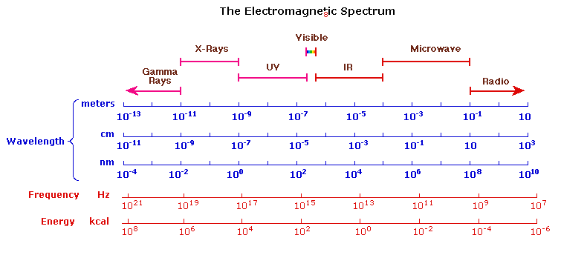

Electromagnetic Wave Detection
Electromagnetic Wave Detection Sensor is used to detect and display electromagnetic wave strength.
And this version is V3.0 module and include all of the function of both of the V2.0 and V1.0. The V3.0 module has two kinds of output way: one kind is the voltage display electromagnetic wave strength and the other kind is the LED display electromagnetic wave strength. EMF detector is a test and measurement apparatus that is used in different industrial applications for detecting problems in electrical wiring and power lines. The EMF meter gives information about the workflow in the electromagnetic field by measuring electromagnetic radiation flux density (DC). Moreover, this instrument can track the changes in the electromagnetic field that occur over a confident period of the time (AC fields). The EMF meters detect issues in the electromagnetic field by the measurable changes in the quantity of electric or magnetic energy that flows in the field that is being precise. This is complete with the highly-sensitive components which are part of the arrangement of this test and measurement device. According to the fluctuations in the quantity of electric or magnetic energy (if there are any), the EMF meter can specify existent issues in the work of the electrical wiring and power lines. Using this method, bigger problems can be prevented and proper workflow in the manufacturing sites is ensured.

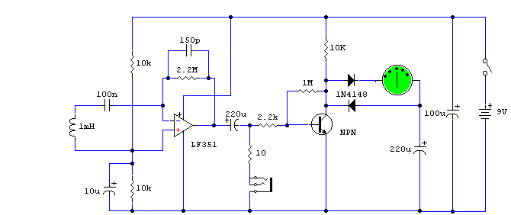

Alpha
Alpha radiation consists of positively (+2) charged particles emitted from the nucleus of an atom in the process of decay. These particles are also very dense which, with their strong positive charge, precludes them from penetrating more than an inch of air or a sheet of paper. Because of this, Alpha particles are not a serious health hazard, except when they are emitted from within the body as a result of ingestion, for instance, when their high energy poses an extreme hazard to sensitive living tissue. A weak form of ionizing radiation detectable on some models of Geiger counters, typically those that incorporate a thin mica window at one end of the Geiger -Mueller tube.

Beta
Beta radiation consists of negatively charged (-1) particles emitted from an atom in the process of decay. These particles are relatively light and can penetrate somewhat better than an Alpha particle, though still only through a few millimeters of aluminum at best. If ingested, Beta radiation can be hazardous to living tissue. A relatively weak form of ionizing radiation detectable on many Geiger counters, generally dependent on the thickness of the Geiger-Mueller tube wall or the existence of a window at the end of the tube.

Gamma
Gamma radiation represents one extreme of the electromagnetic spectrum, particularly that radiation with the highest frequency and shortest wavelength. (That same spectrum also includes the more familiar X-rays, ultraviolet light, visible light, infrared rays, microwaves, and radio waves, listed in order of decreasing frequency and increasing wavelength from Gamma rays.) Gamma rays can pass through virtually anything, and are effectively shielded or absorbed only by materials of high atomic weight such as lead. Gamma rays are produced naturally by the sun and other bodies in outer space, their transmission to earth is known as "cosmic radiation". A very powerful and potentially very dangerous type of ionizing radiation detectable on virtually all Geiger counters.

Background Radiation
Certain minerals that makeup part of the earth containing the radioactive elements Uranium and/or Thorium also emit Gamma rays. This, along with the cosmic radiation (Gamma rays which come from the sun and other stars), combine to produce the "background count" of a Geiger counter. This might typically be in the range of 15 to 60 counts per minute but will vary depending upon your location on the earth, your altitude, and the efficiency of the Geiger counter. The background count should always be factored in or "subtracted" from the overall reading derived from a specific radioactive source. Common background radiation goes from 0.041μSv/h to 0.081μSv/h (3650 - 7200μSv/year).
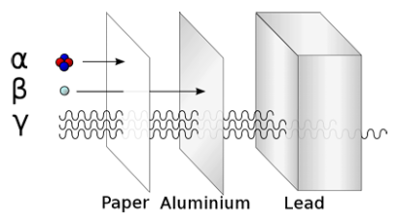

LITERATURE REVIEW
In recent years, due to technology advances human lives are subjected to high level of Electromagnetic emission. Effects of Electromagnetic Radiation (EMR) on human health is one of the most significant concerns in the world. The present paper recognizes the possible health hazard on humanity by exposure of Electromagnetic radiations (EMR). Potential of electromagnetic radiation can radiate through transmission lines which are very close to human's life. The effects of the radiations are classified into two main categories that are known as ionization and non-ionization radiation. Ionization radiations have high energy that impacts on the atoms in the cells, which leads to change their natural status, however, they can be too dangerous and lethal, and can lead to cancer and other diseases. On the other hand, non-ionization radiations consist of electromagnetic radiations such as communication waves, microwaves, and electrical waves.

IV. Prior art
This is a very large field of research as considering the effect of electromagnetic radiation on humans as well on other living beings as well as electric and electronic devices. There are many small devices developed which are used for checking the radiation by mobile.
But there is no development of CANSAT for checking the electromagnetic radiation level. So we are developing the system which measures the required data and sends it to the ground station.

CONCLUSION
The haptic feedback system would make it possible for human beings to experience a new “sense” through the existing sense of touch; the integration of these senses may open up new avenues of research in the field of neuroscience as well.

Acknowledgment
The Author is grateful to satellite estimation and ground electromagnetic radiating rays index and prior art search for providing me such important information.

References

- Kazimierczuk, Marian K. High-Frequency Magnetic Components. pp27-29 2011.
- Milligan, Thomas A. Modern Antenna Design. pp 259-262. 2005.
- Seran, H.C. and Fergeau, P. An optimized low-frequency three-axis search coil magnetometer for space research. AIP: Review of Scientific Instruments. 76, 044502 (2005).

ETHICAL CONSIDERATIONS
We commit ourselves to abide by the ethical code laid down by the IEEE. A few considerations specific to our product are outlined below.
- Safety may be of concern if this product will be used in areas of high radiation density. To this effect, we will implement a safety mechanism to ensure that currents do not exceed normal levels.
- Many Electromagnetic Field Detectors are marketed as Ghost Hunting Devices. As no evidence is currently available to us regarding the viability of this application, we clearly state that our product is not intended for detecting paranormal activity.
- Developing this product for a doctoral student in the neuroscience program requires that the team not promise to deliver a product that may not meet specifications or may be excessively costly.

